A KPI ‘S
1.Total Revenue:
SELECT SUM(total_price) AS Total_revenu
FROM pizza_sales
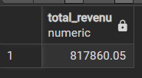
2. Average Order Value
SELECT SUM(total_price) / COUNT(DISTINCT order_id) AS Average_order_value
FROM pizza_sales
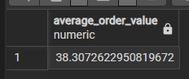
3. Total Pizzas Sold
SELECT SUM(quantity) AS Total_pizza_sales
FROM pizza_sales
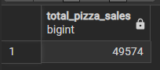
4. Total Orders
SELECT COUNT(DISTINCT order_id) AS Total_Orders
FROM pizza_sales
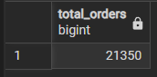
5. Average Pizzas Per Order
SELECT ROUND(SUM(quantity)::numeric / COUNT(DISTINCT order_id)::numeric,2) AS avg_pizzas_per_order
FROM pizza_sales
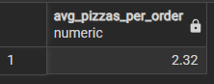

B. Daily Trend for Total Orders
SELECT
EXTRACT (DOW FROM order_date) AS DOW, --EXTRACT USE TO 0 → Sunday 1 → Monday .....6 →Saturday
TRIM (TO_CHAR (order_date,'DAY')) AS Order_day,--Converts the date into the day name: Monday, Tuesday, etc.
COUNT (DISTINCT order_id) AS Total_order
FROM pizza_sales
GROUP BY DOW, Order_day
ORDER BY DOW

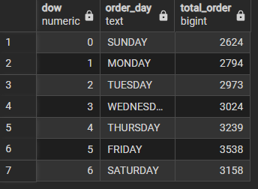

C. Hourly Trend for Orders
SELECT
EXTRACT(HOUR FROM order_time) AS Order_hours,
COUNT(DISTINCT order_id) AS Total_order
FROM pizza_sales
GROUP BY Order_hours
ORDER BY Order_hours
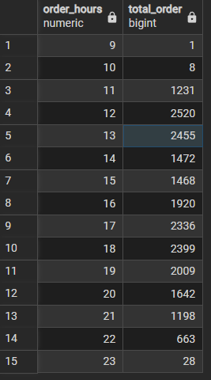

D. % of Sales by Pizza Category
SELECT pizza_category,
ROUND(SUM(total_price)::NUMERIC,2)AS Total_revenue,
ROUND(SUM(total_price) * 100.0 / (SELECT SUM(total_price) FROM pizza_sales),2) AS PCT
FROM pizza_sales
GROUP BY pizza_category
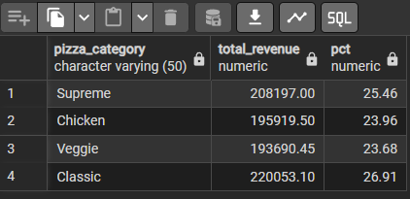
E. % of Sales by Pizza Size
SELECT pizza_size,
ROUND(SUM(total_price)::numeric, 2) AS total_revenue,
ROUND(SUM(total_price) * 100.0 / (SELECT SUM(total_price) FROM pizza_sales),2) AS PCT
FROM pizza_sales
GROUP BY pizza_size
ORDER BY pizza_size
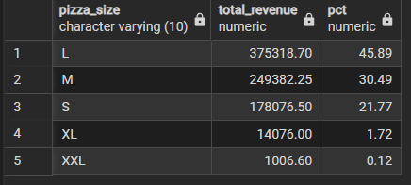

F. Total Pizzas Sold by Pizza Category
SELECT pizza_category,SUM(quantity) AS total_quantity_sold
FROM pizza_sales
WHERE EXTRACT(MONTH FROM order_date) = 2
GROUP BY pizza_category
ORDER BY total_quantity_sold DESC;
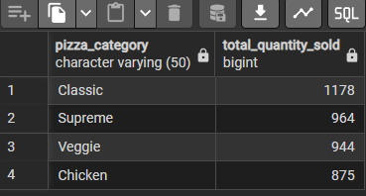

G. Top 5 Best Sellers by Total Pizzas Sold
SELECT pizza_name,SUM(quantity) AS total_pizza_sold
FROM pizza_sales
GROUP BY pizza_name
ORDER BY total_pizza_sold DESC
LIMIT 5;
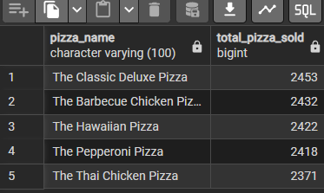

H. Bottom 5 Best Sellers by Total Pizzas Sold
SELECT pizza_name,SUM(quantity) AS total_pizza_sold
FROM pizza_sales
GROUP BY pizza_name
ORDER BY total_pizza_sold ASC
LIMIT 5;
